# Creating the Azure Data Lake Storage

The User Interface for creating the Azure Storage Account has slightly changed recently. Changes are very small, but please follow the instructions here if you get stuck!

1. Basics

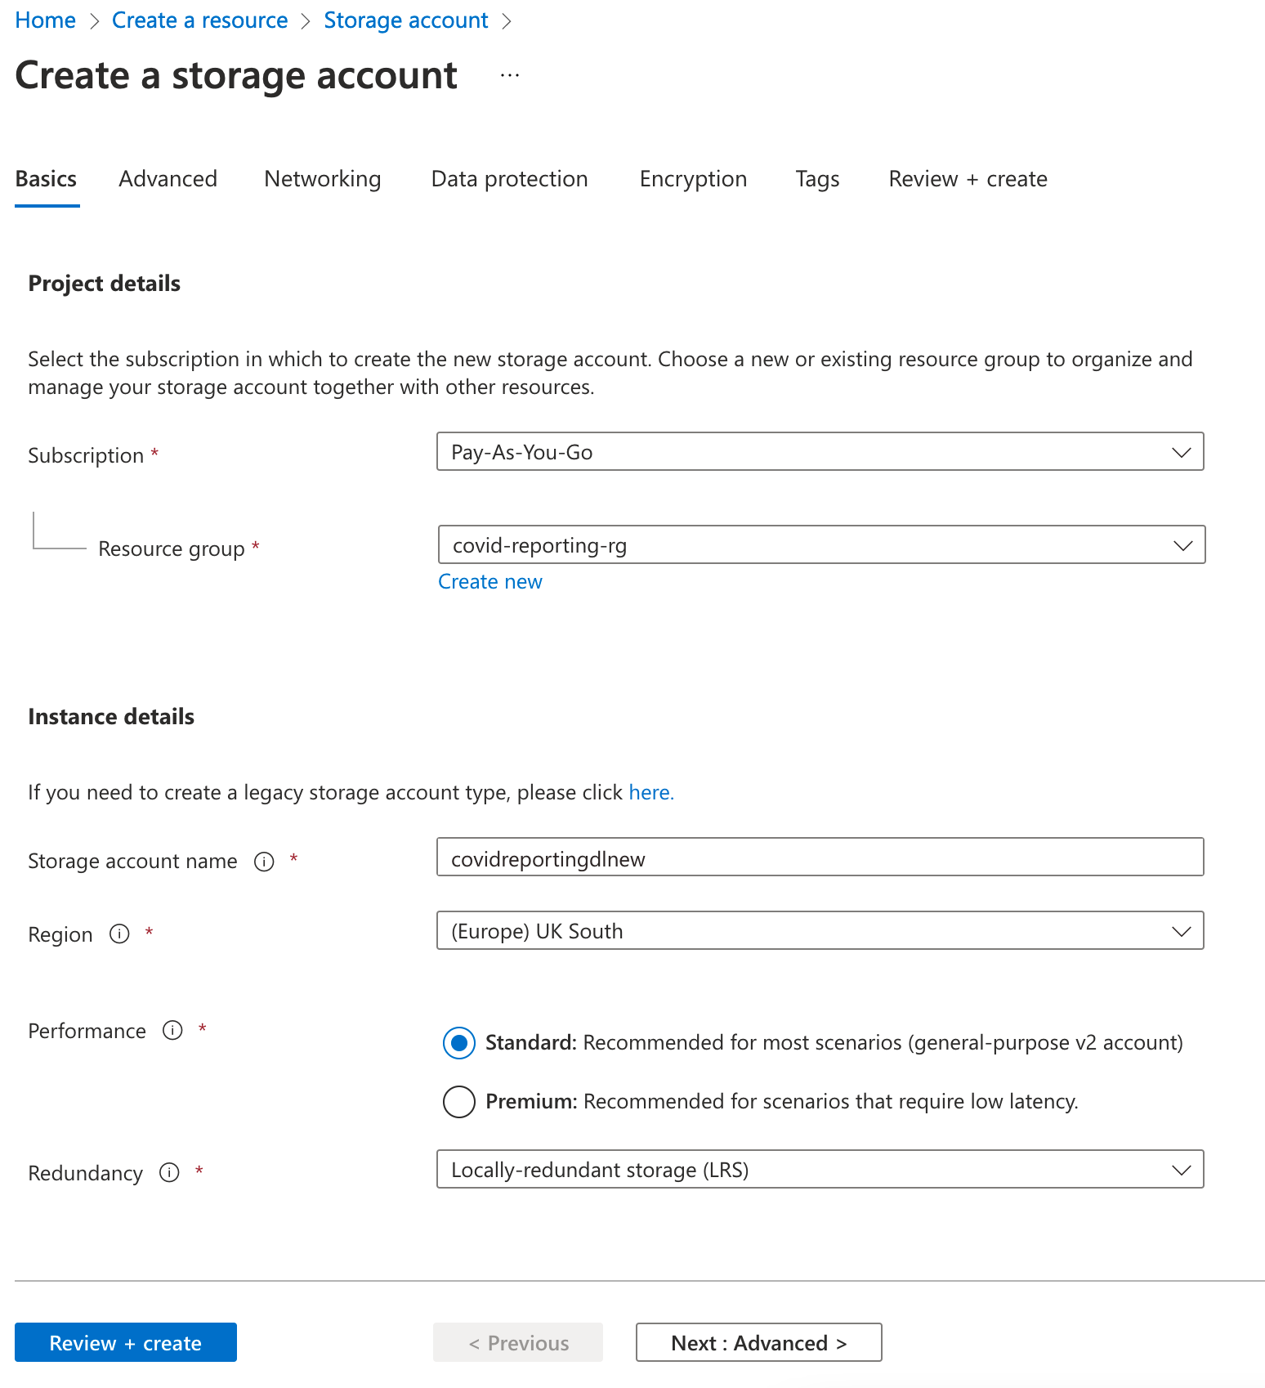

1. Advanced – Please select “Enable Hierarchical Namespace”

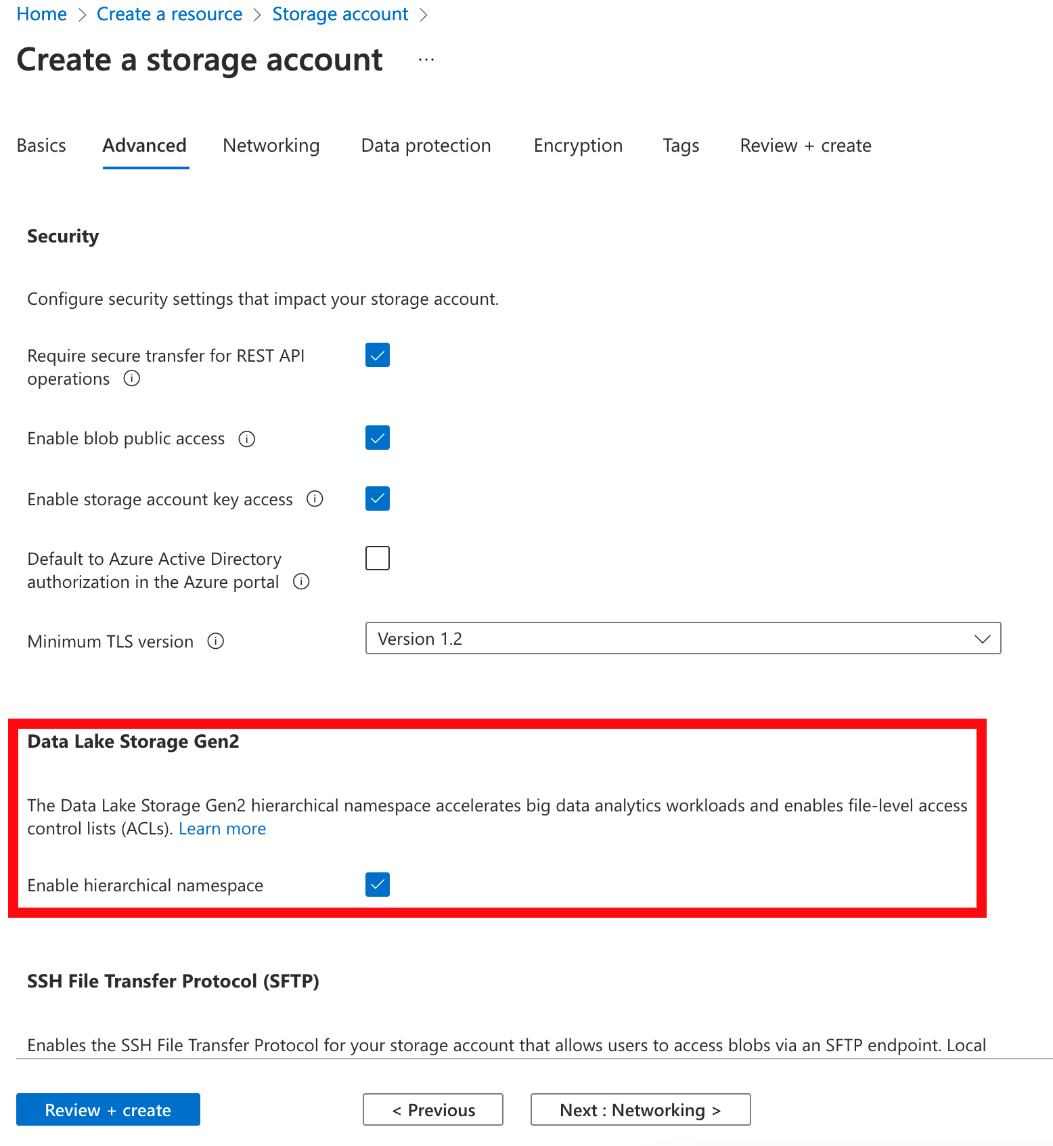

1. Networking – Access the defaults

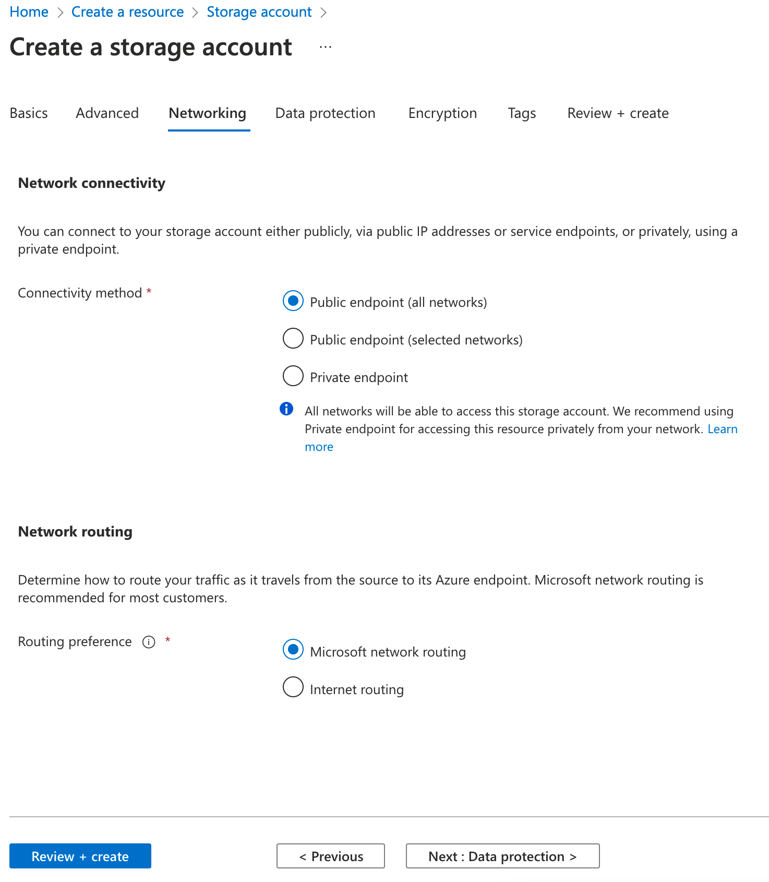

1. Data Protection – Please untick the soft deletes

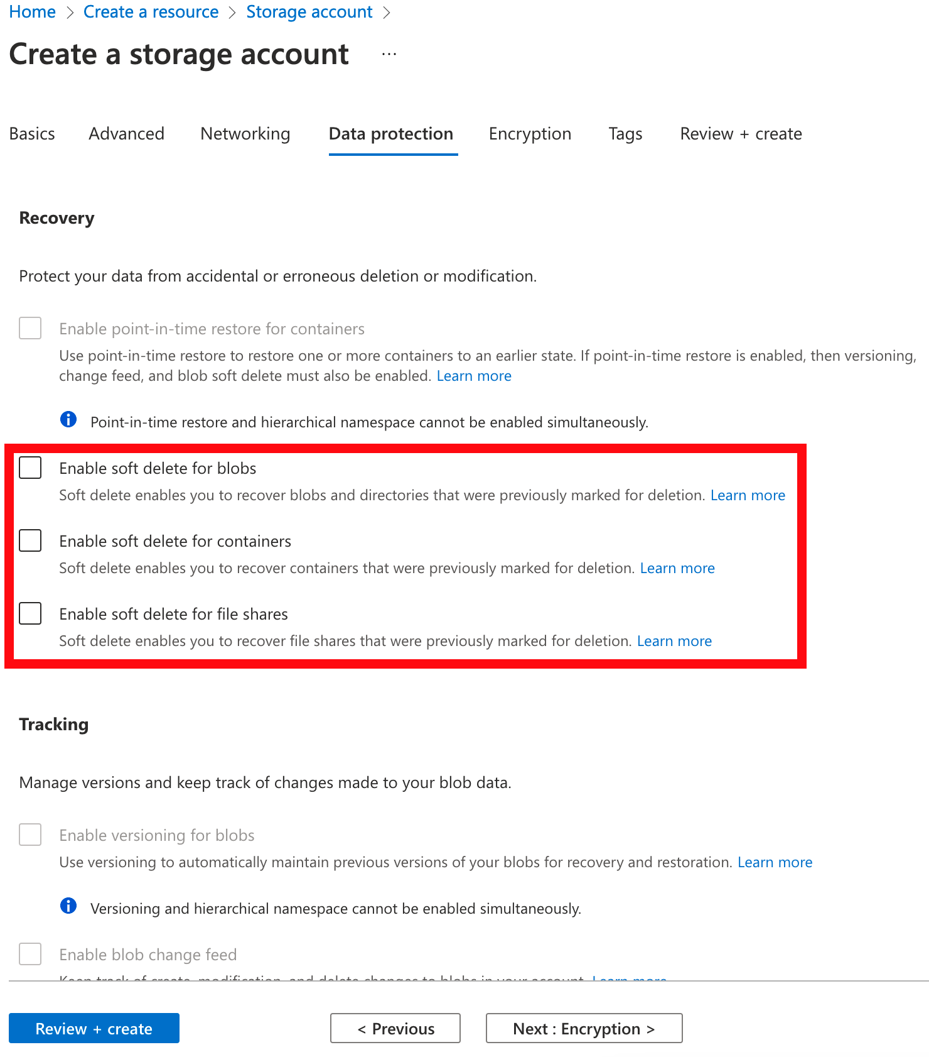

1. Encryption – Accept the defaults

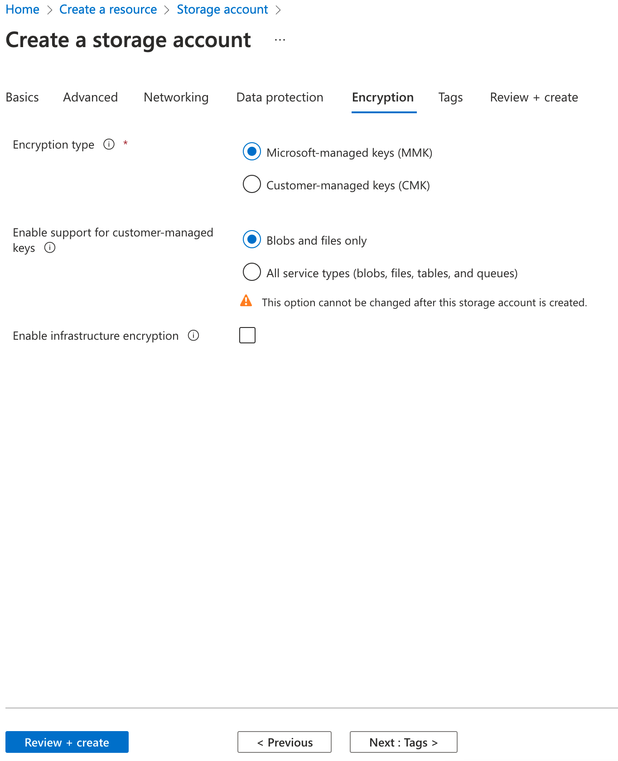

1. Tags – Accept defaults

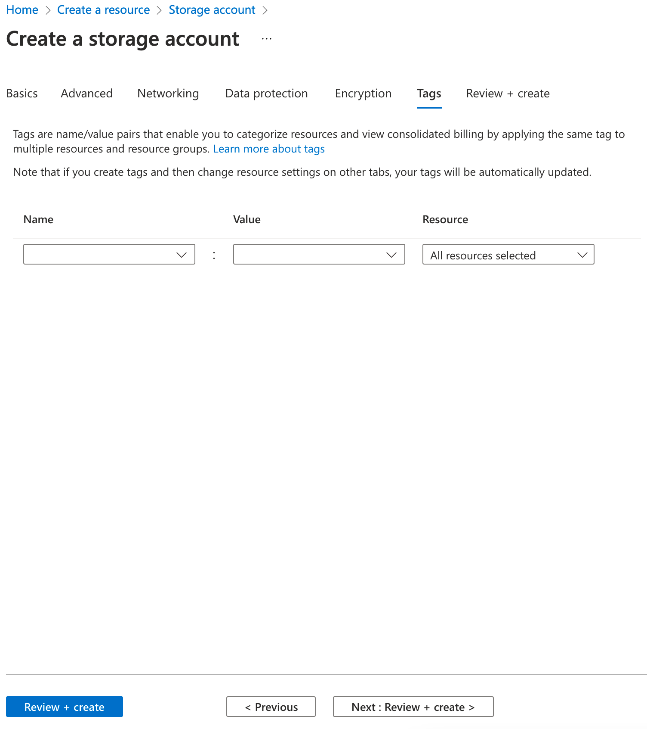

1. Review + Create – Click on Create to deploy the storage account

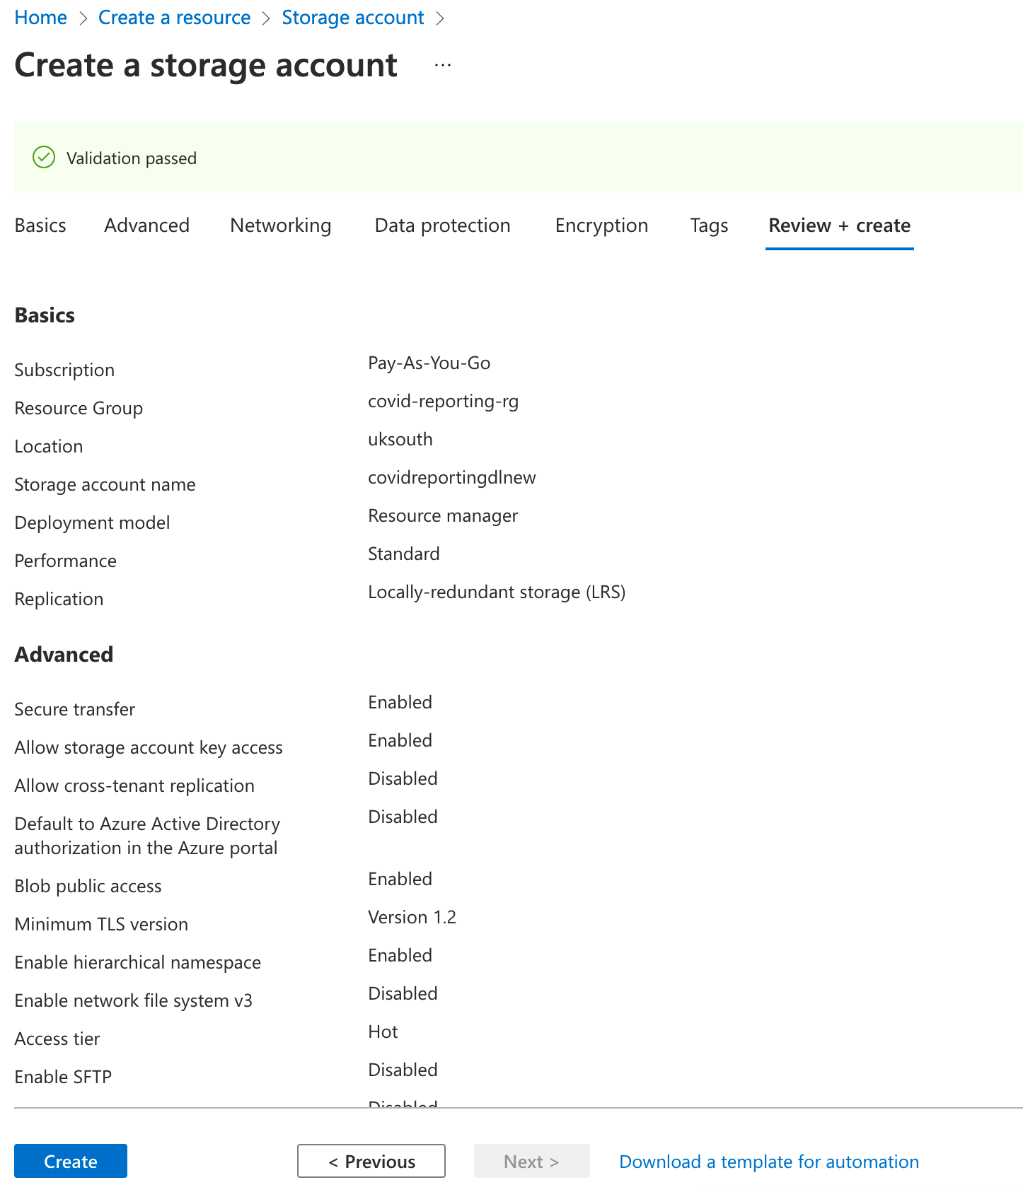

1. Storage Explorer is now hidden under the Storage Browser menu. Please click on the switch back button if you would prefer the storage explorer UI

